2200031128 CH BHAVANA
WEEK 8 TASK 2
Objectives
- Explain git ignore
- Explain how to ignore unwanted files using git ignore
In this hands-on lab, you will learn how to:
- Implement git ignore command to ignore unwanted files and folders
Prerequisites
The following are the pre-requisites to complete this hands-on lab:
- Setting up Git environment
- Integrate notepad++ as a default editor
- A Git repository in the local system and a remote repository in GitLab
Notes*:
Please follow the below steps for creating a free account in GitHub.
Do not use cognizant credentials to login to GitHub.

Estimated time to complete this lab: 20 minutes.
Create a “.log” file and a log folder in the working directory of Git. Update the .gitignore file in such a way that on committing, these files (.log extensions and log folders) are ignored.
Verify if the git status reflects the same about working directory, local repository and git repository.

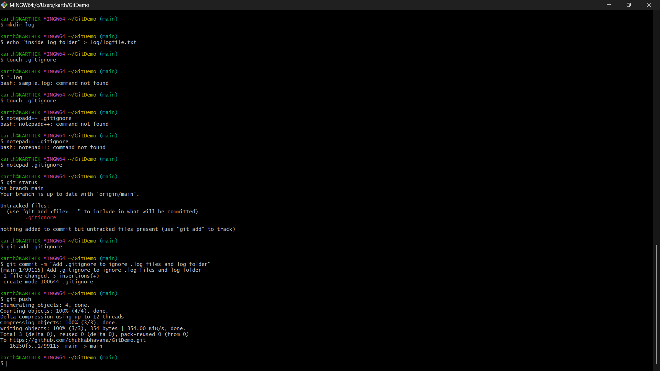
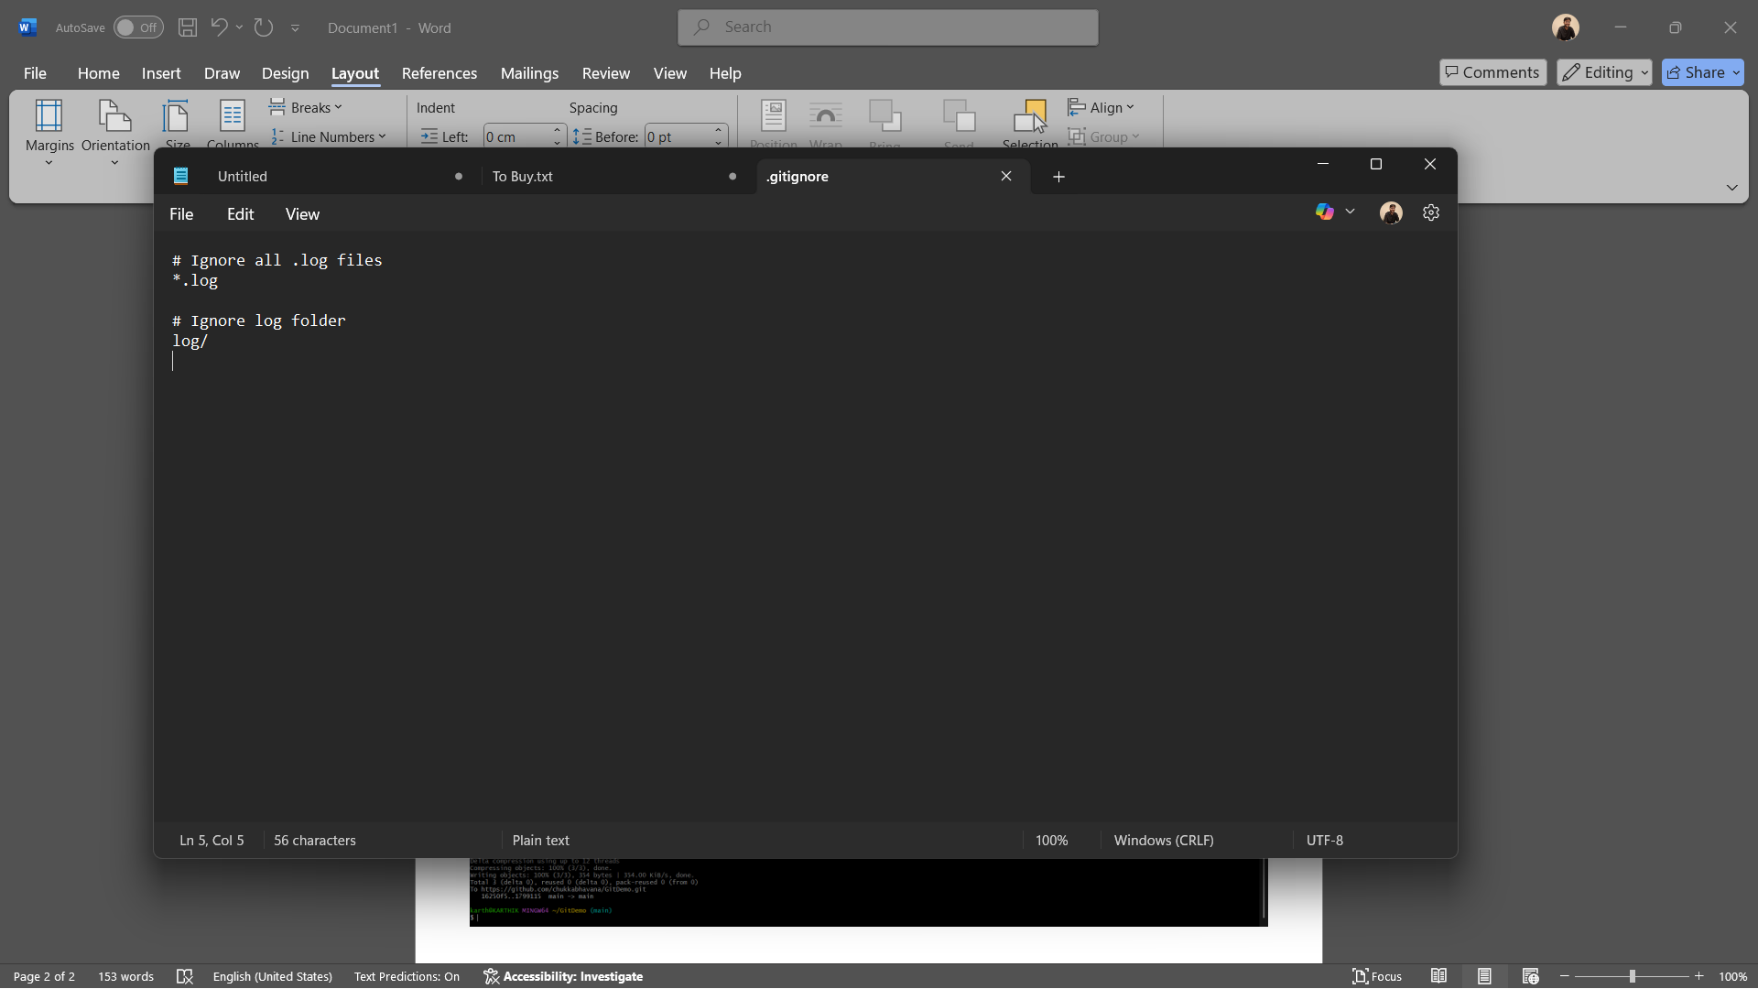
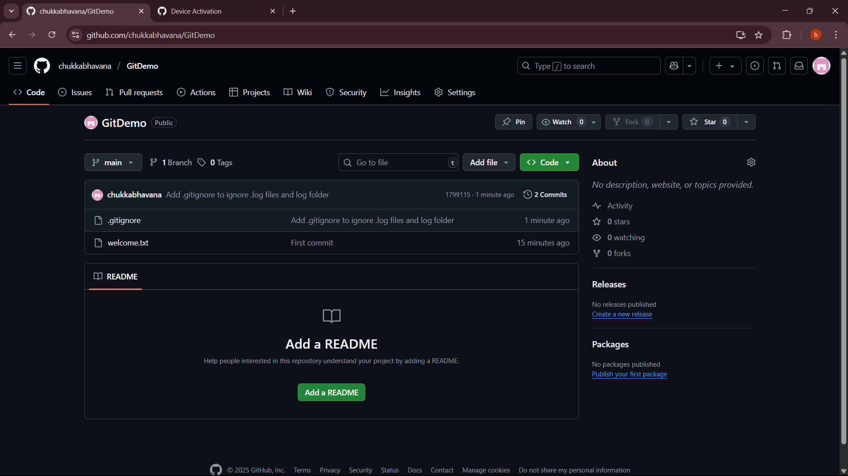
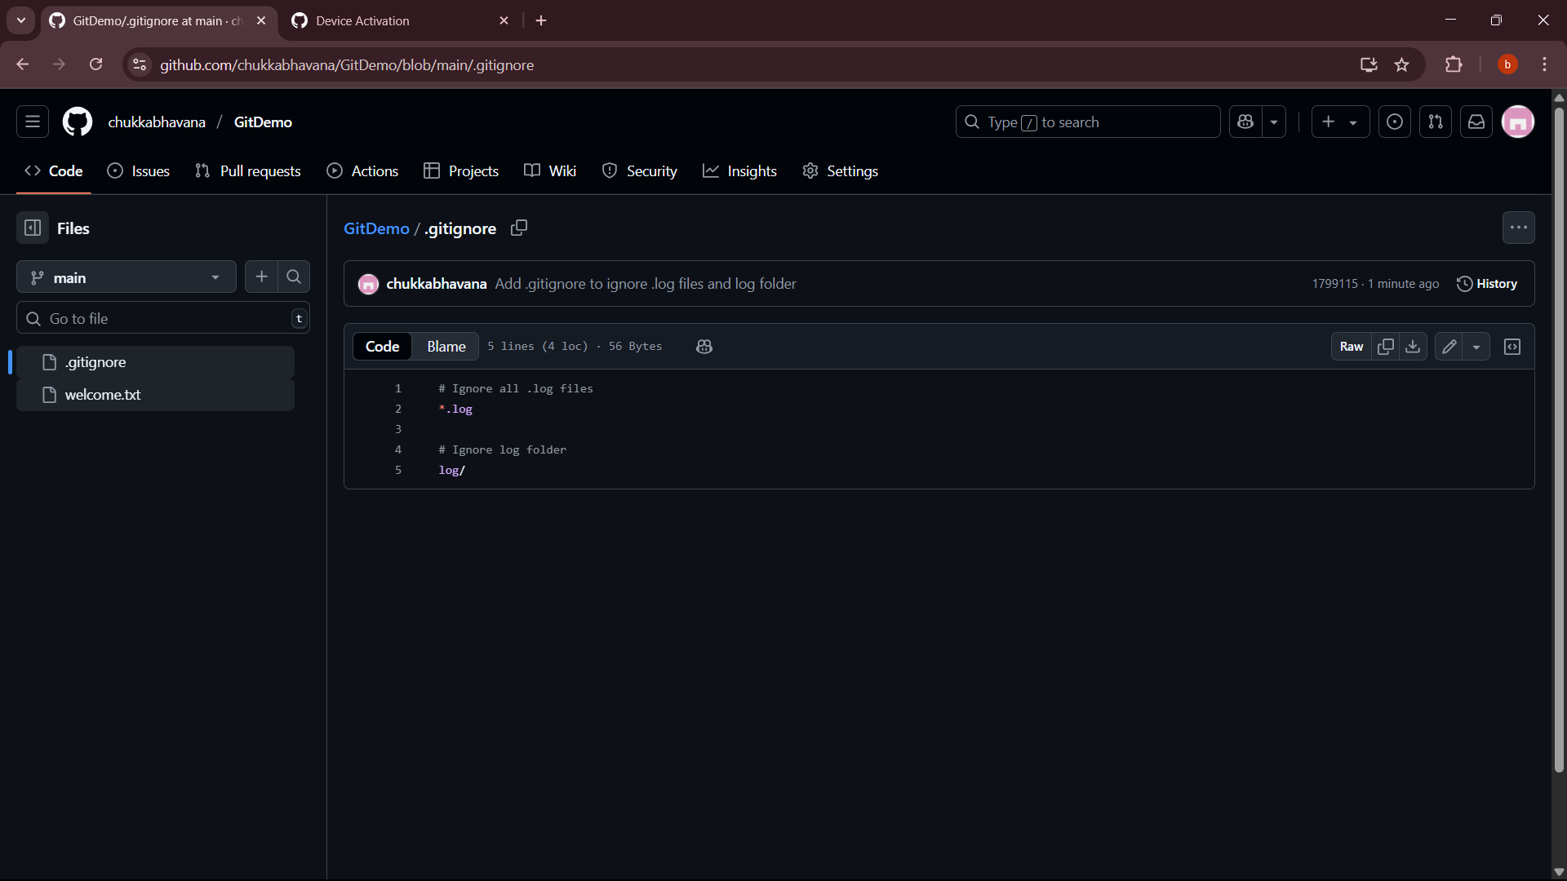
• Purpose of .gitignore
- .gitignore is a plain text file that tells Git which files and folders it should not track.
- This is useful for ignoring:
  - Temporary files (.log, .tmp, .bak)
  - Build outputs (/bin, /dist)
  - Sensitive files (.env, API keys)
  - OS-generated files (Thumbs.db, .DS_Store)
• How .gitignore works
- Git reads patterns in .gitignore and skips adding matching files to the staging area.
- It only applies to files not already tracked.
- If a file is already committed, adding it to .gitignore won’t remove it — you must untrack it with git rm --cached.
• Creating the ignored files/folders
- You created a .log file (sample.log) and a folder named log to demonstrate ignoring.
- Initially, these files would appear in git status as untracked.
• Adding ignore rules
- In .gitignore you wrote:
*.log
log/
  - *.log → matches all files ending in .log (anywhere in the repo).
  - log/ → matches the folder named log and everything inside it.
• Effect on git status
- After saving .gitignore, running git status no longer showed sample.log or the log/ folder — they were ignored.
• Tracking .gitignore itself
- .gitignore is important to share with collaborators so everyone ignores the same files.
- You staged and committed .gitignore so it’s stored in the repo and available to others.
• Pushing changes
- Pushing sent the .gitignore to the remote repository.
- The ignored files remain only on your local machine; they are not uploaded.
• Key rule
- .gitignore only prevents new files from being tracked. If you’ve already committed a file, Git will keep tracking it until you explicitly remove it from the index.

